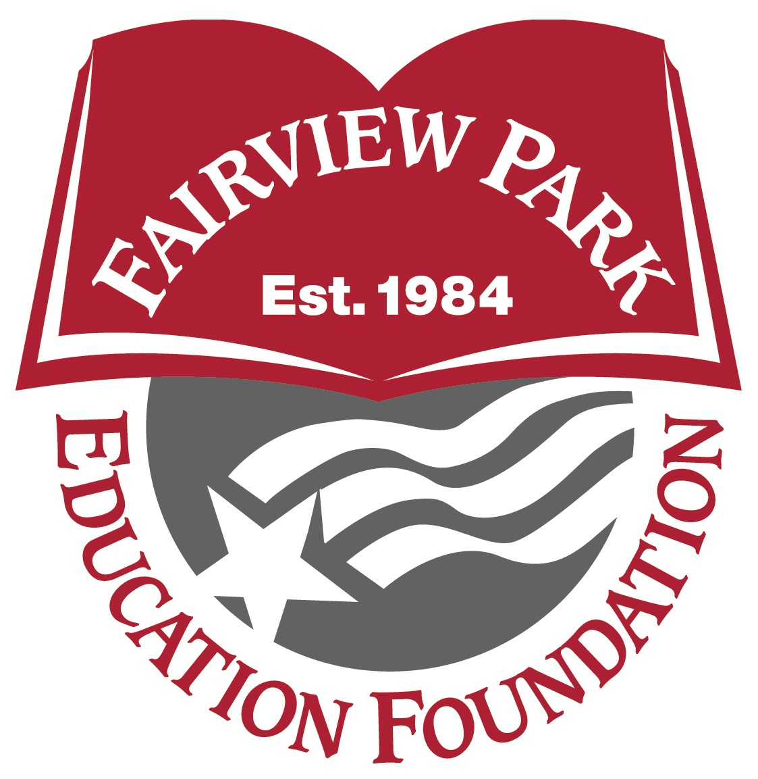
GRANT PROPOSAL
SPRING, 2024
Deadline
Friday, April 5, 2024
Date:

Project/Program Title:

School:

Principal ______________________________________________________________

Anticipated number of students participating in grade(s)

Proposer Name(s):

Home Address:

Email Address: _________________________________________

Phone Numbers: School Home

THE APPLICATION SHOULD BE FILLED OUT ON THIS PAPERWORK ONLY. PLEASE
ANSWER ALL OF THE QUESTIONS BELOW SO WE HAVE A BETTER UNDERSTANDING
OF THE GRANT. ADDITIONAL INFORMATION REGARDING THE PROJECT
OR PROGRAM MAY BE ATTACHED TO THIS APPLICATION.

Grants will be awarded within the parameters of the six goals as follows:
- To support various projects in subject areas for grades PK-12.
- To support special programs within a school building
- To support subject areas by bringing visiting instructors, lecturers, and speakers into the district.
- To support cultural enrichment opportunities through special musical, dramatic, and artistic performances.
- To support small-scale educational research and development programs for enhancing student learning.
- To support other programs initiated by the faculty, administration, Board, and citizens.

1. Full description of the project/program, the PURPOSE, and your INVOLVEMENT:

2. The RESULTS anticipated from the project/program:

3. Proposed means for EVALUATING the project/program:

4. Proposed SCHEDULE for the project/program:

5. ESTIMATE OF EXPENSES – list or describe items included, in detail:

You may submit your proposal via email to:

Jean Scothon, Chairman, Grants Committee at jscothon4@gmail.com by Friday, April 5, 2024

